Ex. No. : 04 Date: 30-02-2026
Register No.: 231701043 Name: Ragul M

Gesture-Based Interaction App
Aim
To design and develop an Android application using Kotlin that can detect and handle various user gestures such as single tap, double tap, long press, and swipes in different directions.

Procedure:
- Lanch Android Studio and create a new project using the Empty Views Activity template.
- Choose Kotlin as the programming language for the project.
- Design the user interface in activity_main.xml using a ConstraintLayout containing a TextView to display messages.
- Create another activity named MainActivity2 to handle gesture detection.
- Implement gesture recognition within this activity.
- Use GestureDetector to detect the following gestures:
a. Single Tap
b. Double Tap
c. Long Press
- Implement manual swipe detection using MotionEvent to identify:
a. Swipe Right
b. Swipe Left
c. Swipe Up
d. Swipe Down
- Attach a setOnTouchListener to the layout to capture and process touch events.
- Update the displayed message dynamically by using setText() with string values defined in strings.xml.
- Register the second activity in the AndroidManifest.xml file.
- Run the application on an emulator or a physical Android device.
- Test different gestures on the screen and observe the corresponding responses displayed in the application.
AndroidManifest.xml

<?xml version="1.0" encoding="utf-8"?>
<manifest xmlns:android="http://schemas.android.com/apk/res/android"
xmlns:tools="http://schemas.android.com/tools">
<application
android:allowBackup="true"
android:dataExtractionRules="@xml/data_extraction_rules"
android:fullBackupContent="@xml/backup_rules"
android:icon="@mipmap/ic_launcher"
android:label="@string/app_name"
android:roundIcon="@mipmap/ic_launcher_round"
android:supportsRtl="true"
android:theme="@style/Theme.Text">
<activity android:name=".MainActivity2" />
<activity
android:name=".MainActivity"
android:exported="true">
<intent-filter>
<action android:name="android.intent.action.MAIN" />
<category android:name="android.intent.category.LAUNCHER" />
</intent-filter>
</activity>
<meta-data
android:name="preloaded_fonts"
android:resource="@array/preloaded_fonts" />
</application>
</manifest>

Activity_main.xml

<?xml version="1.0" encoding="utf-8"?>
<androidx.constraintlayout.widget.ConstraintLayout
xmlns:android="http://schemas.android.com/apk/res/android"
xmlns:app="http://schemas.android.com/apk/res-auto"
android:id="@+id/main"
android:layout_width="match_parent"
android:layout_height="match_parent"
android:background="#E3F2FD">
<TextView
android:id="@+id/tvMain"
android:layout_width="wrap_content"
android:layout_height="wrap_content"
android:fontFamily="@font/crete_round"
android:gravity="center"
android:text="@string/main_message"
android:textSize="22sp"
android:textStyle="bold"
app:layout_constraintBottom_toBottomOf="parent"
app:layout_constraintEnd_toEndOf="parent"
app:layout_constraintStart_toStartOf="parent"
app:layout_constraintTop_toTopOf="parent" />
</androidx.constraintlayout.widget.ConstraintLayout>
Activity_main2.xml
<?xml version="1.0" encoding="utf-8"?>
<androidx.constraintlayout.widget.ConstraintLayout
xmlns:android="http://schemas.android.com/apk/res/android"
xmlns:app="http://schemas.android.com/apk/res-auto"
android:id="@+id/main"
android:layout_width="match_parent"
android:layout_height="match_parent"
android:background="#C8E6C9">
<TextView
android:id="@+id/tv2"
android:layout_width="wrap_content"
android:layout_height="wrap_content"
android:fontFamily="@font/crete_round"
android:gravity="center"
android:text="@string/gesture_default"
android:textAlignment="center"
android:textSize="24sp"
android:textStyle="bold"
app:layout_constraintBottom_toBottomOf="parent"
app:layout_constraintEnd_toEndOf="parent"
app:layout_constraintStart_toStartOf="parent"
app:layout_constraintTop_toTopOf="parent" />
</androidx.constraintlayout.widget.ConstraintLayout>

MainActivity.kt

package com.example.text

import android.content.Intent
import android.os.Bundle
import android.view.GestureDetector
import android.view.MotionEvent
import androidx.appcompat.app.AppCompatActivity
class MainActivity : AppCompatActivity() {
private lateinit var gestureDetector: GestureDetector
override fun onCreate(savedInstanceState: Bundle?) {
super.onCreate(savedInstanceState)
setContentView(R.layout.activity_main)
gestureDetector = GestureDetector(this, GestureListener())
}
inner class GestureListener : GestureDetector.SimpleOnGestureListener() {
override fun onDown(e: MotionEvent): Boolean {
return true
}
override fun onDoubleTap(e: MotionEvent): Boolean {
val intent = Intent(this@MainActivity, MainActivity2::class.java)
startActivity(intent)
return true
}
}
override fun onTouchEvent(event: MotionEvent): Boolean {
gestureDetector.onTouchEvent(event)
return super.onTouchEvent(event)
}
}

MainActivity2.kt

package com.example.text

import android.os.Bundle
import android.view.GestureDetector
import android.view.MotionEvent
import android.view.View
import android.widget.TextView
import androidx.appcompat.app.AppCompatActivity
import kotlin.math.abs

class MainActivity2 : AppCompatActivity() {

private lateinit var textView: TextView
private lateinit var gestureDetector: GestureDetector

private var initialX = 0f
private var initialY = 0f

override fun onCreate(savedInstanceState: Bundle?) {
super.onCreate(savedInstanceState)
setContentView(R.layout.activity_main2)

textView = findViewById(R.id.tv2)

gestureDetector = GestureDetector(this, GestureListener())

val rootLayout = findViewById<View>(R.id.main)

rootLayout.setOnTouchListener { v, event ->

gestureDetector.onTouchEvent(event)

when (event.action) {

MotionEvent.ACTION_DOWN -> {
initialX = event.x
initialY = event.y
}

MotionEvent.ACTION_UP -> {

val deltaX = event.x - initialX
val deltaY = event.y - initialY
val threshold = 120

if (abs(deltaX) > abs(deltaY)) {

if (abs(deltaX) > threshold) {
if (deltaX > 0) {
textView.text = getString(R.string.swipe_right)
} else {
textView.text = getString(R.string.swipe_left)
}
}

} else {

if (abs(deltaY) > threshold) {
if (deltaY > 0) {
textView.text = getString(R.string.swipe_down)
} else {
textView.text = getString(R.string.swipe_up)
}
}
}

v.performClick()
}
}
true
}
}

inner class GestureListener : GestureDetector.SimpleOnGestureListener() {

override fun onDown(e: MotionEvent): Boolean {
return true
}

override fun onSingleTapConfirmed(e: MotionEvent): Boolean {
textView.text = getString(R.string.single_tap)
return true
}

override fun onDoubleTap(e: MotionEvent): Boolean {
textView.text = getString(R.string.double_tap)
return true
}

override fun onLongPress(e: MotionEvent) {
textView.text = getString(R.string.long_press)
}
}
}
Output
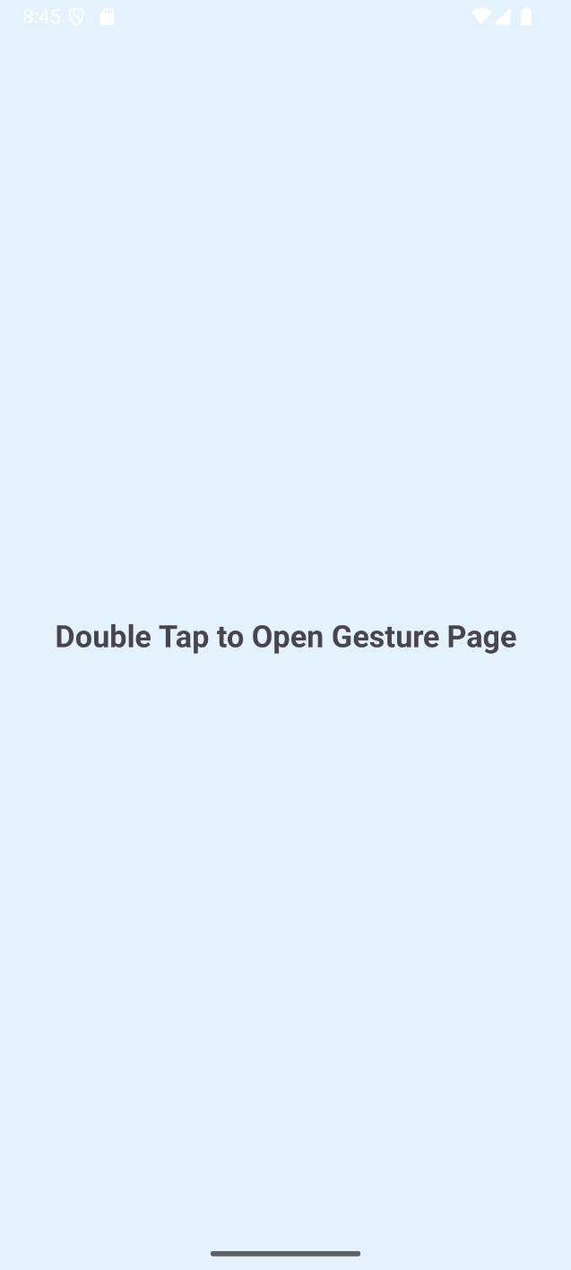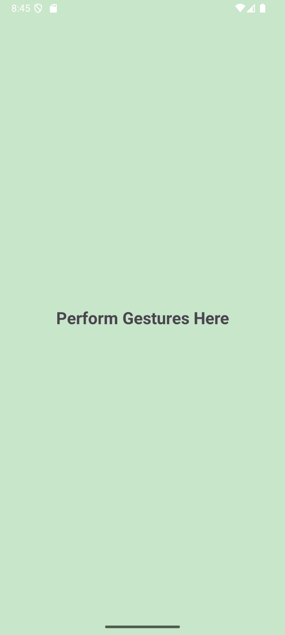

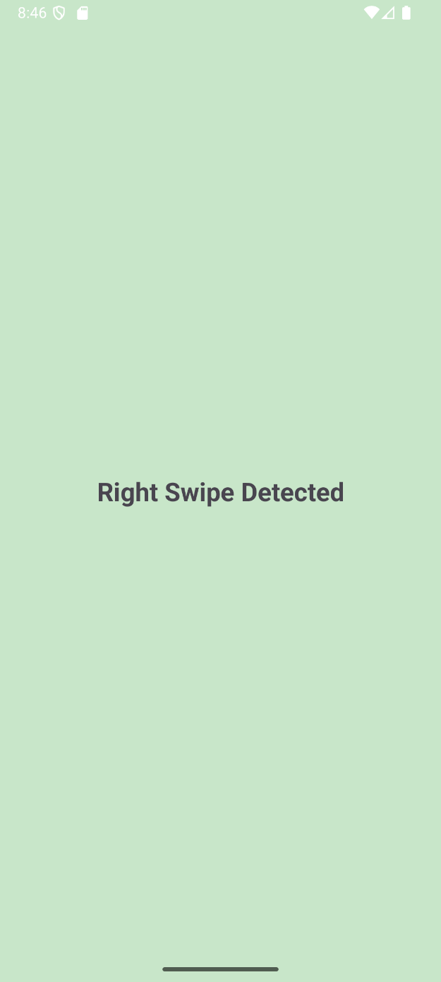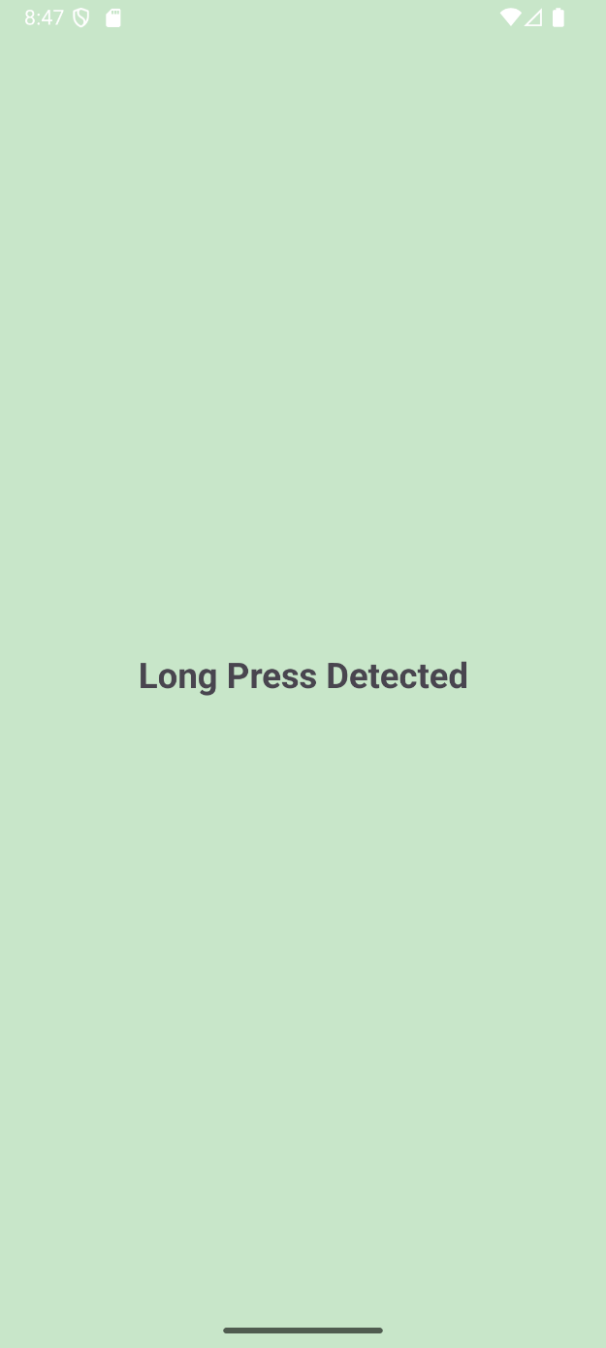

Result:
The application was successfully implemented and tested, and it correctly detects and displays messages for all performed gestures with smooth navigation between activities.

